**Lab Test**

The class under test

public class Promotion {

double promotionRate = 0.0;

public double pro(String gender, int age, double familyIncome, String marital) {

if (gender.equals("female") && familyIncome <= 2000) {

if (age > 40 && marital.equals("other")) {

promotionRate = 20.0 / 100;

} else if (age > 40 && marital.equals("sigle")) {

promotionRate = 10.0 / 100;

} else {

promotionRate = 5.0 / 100;

}

} else if (familyIncome <= 2000) {

if (age > 40 && marital.equals("other")) {

promotionRate = 15.0 / 100;

} else if (age > 40 && marital.equals("married")) {

promotionRate = 10.0 / 100;

} else if (age > 40 && marital.equals("single")) {

promotionRate = 7.0 / 100;

} else {

promotionRate = 5.0 / 100;

}

} else {

promotionRate = 5.0 / 100;

}

return promotionRate;

}

}

1. Assuming the the input of the ***pro*** method in the Class Promotion as the following:

Familyincome ≤ 2000

Age > 40

Marital = { single, married, or other}

Gender= {female, or male }

As test designer, which the best test technique that will be used to derive the most minimum set of test cases oracle. Then, use that technique to come out with the test oracle.

[25 Marks]

* **Equivalent partition** is the best technique to minimize test cases.

|  |  |  |  |  |  |
| --- | --- | --- | --- | --- | --- |
| Test case Id | Input | | | | Expected Result |
| Gender | Age | Familyincome | marital |
| T01 | female | >40 | <=2000 | other |  |
| T02 | female | >40 | <=2000 | single |  |
| T03 | female | <40 | >=2000 | married |  |
| T04 | female | >40 | <=2000 | other |  |
| T05 | male | >40 | <=2000 | married |  |
| T06 | male | >40 | <=2000 | single |  |
| T07 | male | <40 | >=2000 | married |  |
| T08 | male | <40 | >=2000 | single |  |

1. Use the test cases created into the Fault file. Then run the test execution for the method ***pro()*** using the ***LoaderManager tool.***
2. ***Fault*** file that contains ***test cases*** named by your ID [10 Marks]
3. The JTstConstant.java file [5 Marks]
4. The ***Log*** file which is the result of ***LoaderManager*** execution [5 Marks]
5. Print screen of running java in **CMD** and the result from the ***LoaderManager*** [5 Marks]

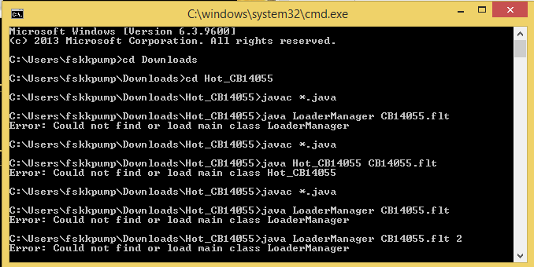

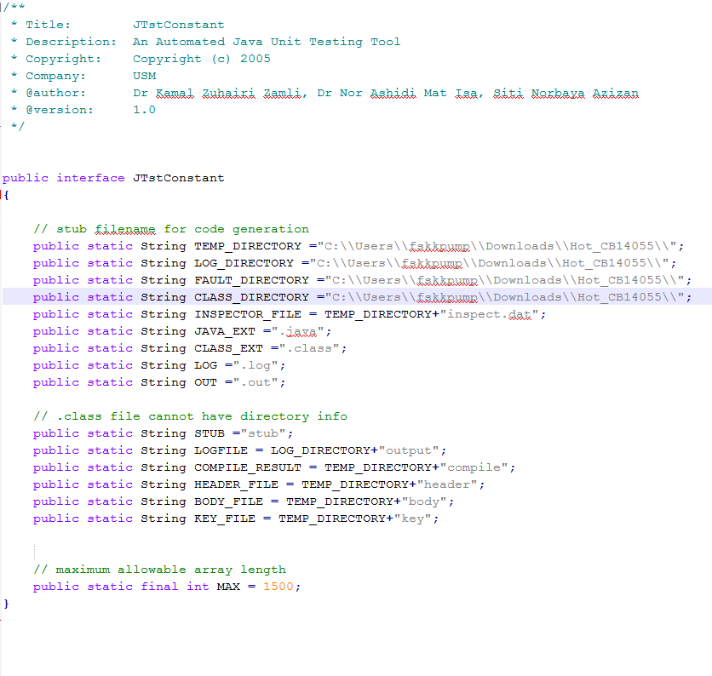

1. Use some test cases from (a) to be used in ***Junit test*** to test the unit ***pro()*** in the class.

And explain what type of testing level is this?

1. The ***PromotionTest.java*** (Text format) the one will be created by ***Juint*** in ***NetBeans***

[10 Marks]

* Acceptance Technique

1. Print screen or save into Microsoft Word file the results of using ***Juint*** test to test the components in the Class ***Promotion***

[20 Marks]

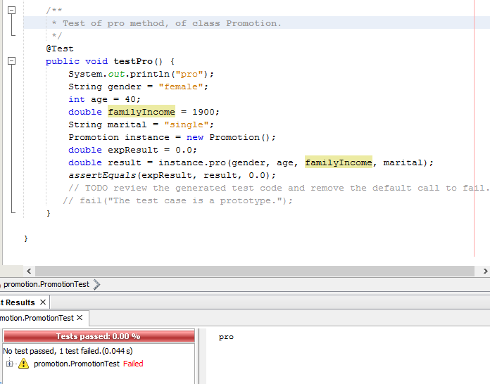

1. Which type of testing technique that can be used to minimize the test cases based on the combinations?

* Equivalent partition technique

[5 Marks]

1. Calculate the minimum test cases could be generated for the system has 10 parameters. The values for the first 3 parameters are 5 and the values for last 4 parameters are 6 and for the values for rest of the parameters are 3, with interaction strength (3). Use the jenny tool and VS-MGA tool to generate the test list. For jenny tool, save the test suite to excel or text file, Print screen of CMD for jenney command. For VS-MGA tool, print screen the of the tool after get the result.

[15 Marks]

|  |
| --- |
|  |

